INFORMATION SYSTEMS IN MANAGEMENT

Information Systems in Management (2016) Vol. 5 (1) 7887

**THE CRITICAL PATH METHOD IN ESTIMATING PROJECT DURATION**

RAFIK NAFKHA a), ARTUR WILIŃSKI b)

a) *Department of Informatics, Warsaw University of Life Sciences* (*SGGW*)

b) *Department of Applied Informatics, Warsaw University of Life Sciences* (*SGGW*)

Undoubtedly, the most important criterion for assessing any project success is to achieve the planned main objective within scheduled time, under the assumed costs and corresponding to established project quality parameters. The article presents critical path method, that aims to determine project schedule which ensure an implementation shortest time. Ultimately, however the optimal project duration is designated after solving human resource deficiencies or conflicts occurring in the generated schedule.

Keywords: Critical Path Method, CPM algorithm, PERT method

**1. Introduction**

Too often, projects that seemed to have real chance of success, may not be performed in accordance with planed expectations and therefore they just fail. We ask then ourselves question whether everything has been done to prevent this matter? Or maybe we did not pay attention to important conditions, which negatively affect the project progressing.

Project term is currently quite intuitively and widely being applied and so the project can be described as a guidance document implementation of any object, a preliminary version of a given device or also an action plan [4]. Frączkowski defined project term as an undertaking (project synonym in the Polish Dictionary [4]) which consists of group of activities having a start date, specific goals and

limits, established implementers responsibilities (duties), budget, schedule and the date of completion [3]. From Wysocki point of view [7], project tasks have to be executed within time limit without budget exceeding, and in accordance with the established requirements. Taking into account conditions that must meet project definitions mentioned by most authors, it can be concluded that, the completion of any project at scheduled time and budget, without exceeding appointed resources and corresponding to the intended quality parameters is strongly associated with appropriate planning [8].

Planning in project management studies is an important and difficult issue. The difficulty results not only from the undertaking complexity, but also its dynamism. Plans are changing all the time, both before its starting and during its implementation. In order to better manage and control projects, a lot of methods are created including those based on network dependences. In order to analyze a duration project in a deterministic term the Critical Path Method (CPM) [3] was created. Using the CPM algorithm, a minimum planned duration project can be determined and for individual project activity both earliest start and latest finish time are than calculated. Since project conditions are changing during its execution, such like resignation or illness of a team member, some project management methods require an input of data values for individual tasks duration as random variables. The simplest and most classic approach here can be The Program Evaluation and Review Technique method, commonly abbreviated PERT [6]. The method requires that individual tasks execution times were given as random variables having beta distribution, represented by three estimation time values: optimistic (shortest) duration, the most likely (mean) duration and pessimistic (longest) duration. Although CPM shares some characteristics with PERT, both have different focus. The article presents a prediction of project time completion and then the management of eventual exceeding planned date using CPM algorithm.

At the beginning activities and events are modeled as a network. Activities are depicted as nodes on the network however events presented as arcs or lines between the nodes and signify the beginning or ending of these activities. The project is determined on the basis of actual relationships existing between project tasks (activities) and its duration. Starting and ending project date are determined by the critical path, which is represented as sequence of different project tasks. Project schedule should be set up on the basis of a number of alternative scenarios. This article presents two kinds of schedules: as-soon-as-possible (ASAP) and as- late-as-possible (ALAP) scheduling algorithms. The first one assumes that all tasks are being to begin and end respectively in the earliest start time (ES) and earliest finish time (EF). The second takes into account only the latest timing i.e. latest start time (LS) and latest finish time (LF). While comparing schedules with each other a verification of overrunning project duration and/or human resources exceeding

79

availability is checked. Any lack of resources availability during task execution will be subject to schedule revision, referred as resources balancing. This may extends the project duration or increase allocated budget. After having reviewed, a new project schedule is adopted.

**2. The project schedule construction**

Completion of the project within the assumed time is one of the basic conditions for successful project termination. Development of activities sequence and assigning necessary resources for their implementation is a basis for project schedule formulation. CPM comprises several steps that can be summarized as follow:

* Create an ordered list with required tasks (activities).

•

•

Create a flowchart or diagram showing each task in relation to the others. Estimate time required to complete each task using past experience or expert knowledge.

Identify the critical and non-critical paths among tasks. The critical path is the longest-duration path through the tasks forming the network.

Determine the expected completion time for each task. Locate or devise alternatives for the most critical paths.

•

•

•

Described steps consisting of identified activities, operations and functions should be placed in a logical sequence for their implementation. Activities may be run sequentially, or simultaneously, i.e. in parallel at the same time. Activities sequence and the relationship between them constitute a starting point for creating a network diagram (Fig. 1). For each activity it is necessary to determine execution time resulting from expert knowledge or similar tasks in similar projects. Once activities and their sequencing have been drown, the critical path can be identified by determining the following four parameters for each task:

•

ES - earliest start time: the earliest time at which the task can start given that its precedent tasks must be completed first.

EF - earliest finish time, equal to the earliest start time for the task plus the time required to complete the task.

LF - latest finish time: the latest time at which the task can be completed without delaying the project.

LS - latest start time, equal to the latest finish time minus the time required to complete the task.

•

•

•

Critical activity for which there is not sufficient time between its earliest and latest start or between its earliest and latest finish time must begin and end on time. Activities not lying on the critical path, have a slack time within which task realization time can be increased without any consequences for the project

80

completion. At this stage a set of preliminary resources (humans, machines etc.) required for individual task implementation is also estimated. In case of lack of resources availability, the schedule has to be updated then new critical path may emerge and structural changes may be made if project requirement change.

**3. CPM Analysis Steps**

Time analysis consists of 6 steps:

**Step 1.** For the first tasks that have not predecessors, let’s make the earliest start

times (tO) zero, and the earliest finish times (tO) equal maximum of concerned task

i

time (tO) and its estimated duration task (tij).

j

i

tO = 0 tO = max(tO +

(1)

tij)

j = 2,3, … . n

1

j

i

i: i<j

(tO) - the earliest start time that has not predecessor.

1

(tij).- tasks time duration.

(*i , j*)*-* activities with starting and final event (*i, j*)*.*

**Step 2**. to calculate the latest time for event (t1), the following formula is used:

i

j = n − 1, n − 2, … .1

t1

= PCT t1 = min(t1 − t )

(2)

n

i

i

i: i<j

tO ≤ PCT usually it is assumed that tO = PCT

n

n

PCT – Specified Project Completion Time (for example fixed project deadline).

**Step 3**. Once calculated the earliest and last starting for each event, the float (or slack (*Li*)) can be calculated.

Li = t1 −

tO

(3)

i i

**Step 4**. The total slack time for any activity *(STij)* is than calculated,

STij = t1 − tO −

tij

(4)

j

i

**Step 5**. Once times required to complete each activity defined, than the following parameters can be than elaborated:

tO

*ESij – Activity (i, j)* earliest start time ESij =

i

*LSij – Activity (i, j)* latest start time LSij = tO + STij

i

*EFij – Activity (i, j)* earliest finish time EFij = t1 − STij

i

t1

*LFij – Activity (i, j)* latest finish time LFij =

j

**Step 6**. The critical path is the path through the project network in which none of the activities have slack, that is, the path for which for all activities in the path, the following formulas are true

*ESij* = *LSij* and *EFij* = *LFij*.

(5)

81

**4. The critical path method in estimating an ERP system implementation duration**

Let’s consider an ERP (Enterprise Resource Planning) system implementation project in a company segmented as small and medium enterprises (SME). The project is led by a three consultants’ team and consists of the following work tasks:

•

Project analysis process – This step represents the official implementation start and includes all activities required to initiate and effectively plan the entire project. During the Analysis phase, gathering and documenting customer’s business requirements, outlining project schedule, milestones, resources, roles and responsibilities are the most important set of activities that must be undertaken when implementing the system.

Software and equipment purchasing - Once the technology options that would fit company needs and goals, have been set, appropriate database and software licenses amount depending on user types and business process areas to be supported have to be purchased. Simultaneously required hardware to run the software is also bought.

Operation System (OS) and Database (DB) installation - As soon as equipments are available, the operating and development system as well as (optional) training system are installed. Suitable database server is also implemented.

Configuration, implementation and system customizing – ERP systems typically include many settings that modify system operations. After completing an initial system implementation, the company has everything to get started using default settings. However system implementation is considerably more difficult than standard installation and initial system configuration in accordance with supplier’s instruction especially in decentralized organizations. Technical solutions include rewriting part of the delivered software, writing a homegrown module to work within the ERP system, or interfacing to an external system.

User training - After proper implementation and testing, the employees of the organization are trained to work on the system before its actually starting. Time and number of people involved for individual task execution are shown in table 1.

•

•

•

•

Network diagram reflecting project implementation sequence and existing dependencies between them, is presented in figure 1. Earliest and latest starting and finishing time, as well as duration of individual tasks, as elaborated in table 2 are shown in figure 1.

82

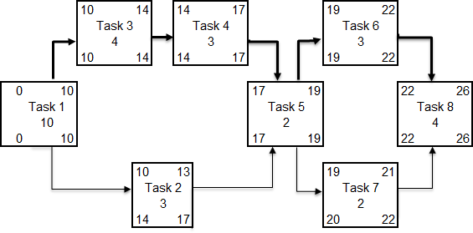

**Table 1.** Tasks considered to implement ERP system

*Source*: own consideration based on [2]

**Figure 1.** Network diagram as adopted in the project

Using CPM algorithm [5], for the adopted example, minimum planed project time realization is specified and for individual task execution earliest and latest start times, ensuring project completion in minimum time realization are calculated.

**Table 2.** The result of CPM algorithm application

*Source*: own calculations based on the CPM algorithm

83

Task

Duration

ES

EF

LS

LF

Slack

T1

10

0

10

0

10

0

T2

3

10

13

14

17

4

T3

4

10

14

10

14

0

T4

3

14

17

14

17

0

T5

2

17

19

17

19

0

T6

3

19

22

19

22

0

T7

2

19

21

20

22

1

T8

4

22

26

22

26

0

Nr

Description

Duration [day]

Staff number

Predece- ssor

T1

Project analysis

10

3

none

T2

Software purchasing

3

1

T1

T3

Hardware and equipments purchasing

4

1

T1

T4

OS and DB installation

3

3

T3

T5

ERP software installation and initial configuration

3

2

T2,4

T6

Business processes implementation

3

2

T5

T7

Implementation in branch offices

2

2

T5

T8

User training

4

1

T6,7

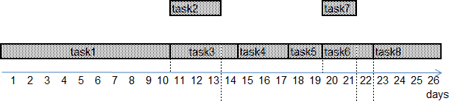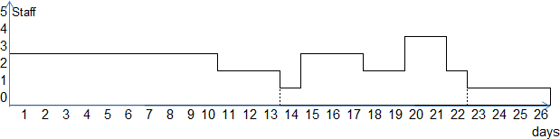

From table 2 it follows that minimum project duration is 26 days. Six tasks (1, 3, 4, 5, 6 and 7) have a slack time equal to 0. These activities have earliest time equal to latest time and thus form a critical path. A delay in this path delays the project. Remaining tasks in this case (2 and 7) have a slack time, i.e. can be delayed past its earliest start or earliest finish without delaying the project. Task 7 has a slack time equal 1 day and, in fact, it is much less than task 2 amounting (4 days). Task 2 has a time margin raising to 4 days and then unlikely does not cause any threat to entire project completion. In certain circumstances if task completion requires early payment, as task 2 (license purchasing), any delay retarding task beginning can be profitable (later payment). To analyze exceeding planned time possibility, the paper presents two types Forward Pass and Backward Pass technique available in the literature [3]. The Forward Pass formula is used moving from the first task to last one in the network diagram. This technique generates ASAP (as soon as possible) schedule and allows to find the earliest start time (ES) and the earliest finish time (EF) for each task (Fig. 2). The second formula is the Backward Pass used by moving from the last task to the first one. This formula generates ALAP (as late as possible) schedule and permits to get the latest start (LS) and latest finish time (LF) for each task (Fig. 4).

**Figure 2.** ASAP schedule in the adapted case

Arranged tasks in a logical sequence for their implementation must be completed with required information about staff number and its availability during tasks execution. Planned human resources in accordance with ASAP schedules are shown in figure 3.

**Figure 3.** Personnel (staff) loading chart for ASAP schedule

84

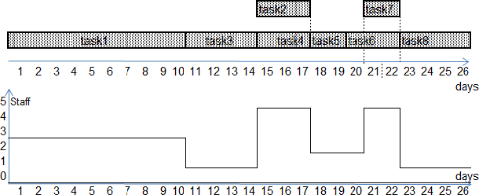

In the ALAP schedule all tasks are planned in accordance with their latest times. Required information about staffs are also added (Fig. 4).

**Figure 4.** Planned tasks and personnel (staff) loading chart for ALAP schedule

From figure 3 and figure 4 it results that in both schedule types, all tasks fit in with the planned implementation time. Analyzing further illustrated schedules in terms of the availability of necessary resources, the assumed available staff (3 persons) during certain implementation period was exceeded: in the ASAP case (4 persons) for 2 days, while during ALAP case (4 persons) within 5 days. Therefore, none of the scheduling resulted from CPM algorithm will be possible to implement and a correction in term of human resources must be provided.

Primary schedule for task implementation often needs to be corrected after consideration of resources allocation and project limitations. Human resources beside budget limitation are often the basic reason to adjust basic schedule. There is another important factor, due to the fact that one particular employee may expected to work on multiple tasks simultaneously. Such situation is called human resource conflict and may be terminated by using load resources equalization (balancing). In this case a shifting in time of certain activities by conversing their parallel exercise to serial form can be considered. This is done in accordance with the principle: among all performed tasks, select the first that has the lowest expected duration and for which there is not enough staff and then move its planned date and start date of all its direct and indirect successors so that the performance of identified tasks subject to staff availability was possible. If the task shift does not fit within its slack time, than a whole project prolongation will be required. In the discussed example, consultants are better distributed over time in the ASAP schedule case and resources adjustment could be applied only during two days instead of 5 days for ALAP schedule, that’s why ASAP schedule is subject to correction. The effect of project tasks shifting over time is depicted in figure 5.

85

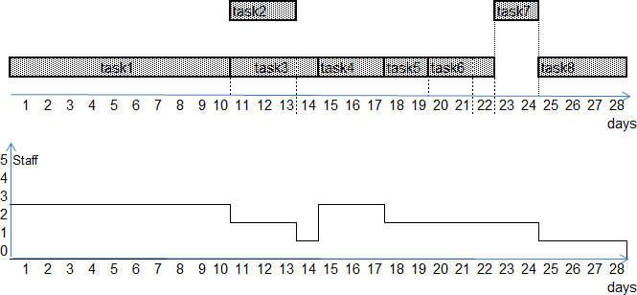

**Figure 5.** ASAP schedule after staff balancing

Once the project completion date in accordance with the revised schedule is accepted, project scheduling process can be considered as complete.

**4. Summary**

The article presented a deterministic model for estimating project time duration. CPM was developed for complex but fairly routine projects with minimal uncertainty in the project completion time. Two schedules type ASAP and ALAP have been used in this paper for designating an ERP implementation project critical path. A complete overview of tasks duration and personal availability associated with its realization is also provided. Based on the adopted case, the application of CPM can be useful in logical discipline in the planning and scheduling of projects. Since individual task duration most often cannot be sure during the planning stage, and for less routine project there is uncertainty in the completion time, the use of deterministic CPM model does not constitute a universal model for estimating project completion time. An alternative to CPM could be PERT planning model, which allows a range of durations (optimistic, average and most pessimistic values), specified for each activity in which implementation time fits with high probability. This case will be examined in the near future.

86

***REFERENCES***

[1]

Frączkowski K. (2003), *Zarządzanie projektem informatycznym*, Wrocław, Oficyna Wydawnicza Politechniki Wrocławskiej

Nafkha R. (2014) *Analiza wybranych metod zarządzania projektem informatycznym we wsparciu procesów biznesowych i organizacyjnych firmy*, IX Scientific Conference, Internet in the information socjety, Dabrowa Górnicza

Punmia B.C., Khandelwal K.K (2002) *Project planning and control with PERT and CPM,* Laxmi Publication (P) LTD

sjp.pl, Polish Dictionary dated (13.11.14)

Skorupka S., Kuchta D., Górski M. (2012) *Zarządzanie ryzykiem w projekcie* Agencja Wydawnicza ARGI, Wrocław

Trzaskalik T. (2008) *Wprowadzenie do badań operacyjnych z komputerem*, PWE Wysocki R K, (2013) *Efektywne zarządzanie projektami*, wydanie 6, Helion

Young T.L. (2006) *Skuteczne zarządzanie projektami*, Wydawnictwo Helion, Gliwice

[2]

[3]

[4]

[5]

[6]

[7]

[8]

87